Rāvòz
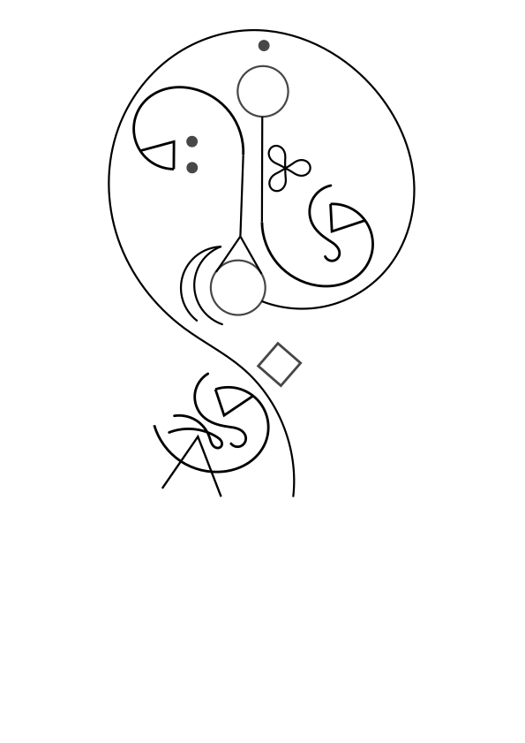

Dictionary
Consonant | i - Animacy | a - Media | o – Adjective (SI/DI)
m | irrealis | generic | important/always
n | causal | information | average/sometimes
ŋ | explanation | vibes | unimportant/never
b | inanimate | coerce | small/likely
d | animate | permission | big/can
p | person | digital/glitch | playful/progressive
t | enigmatic | analog | endless/repetetive
s | experience | pressure/sound | near/habitual
f | waffling | emotion/social | very tall/past
š | self-evident | taste/smell | tall/near past
ž | trusted source | internal/extrasensory | short/near future
v | uncertain source | metacognition/space | deep/far future
z | mistrusted source | heat/light | total/complete
r | nominally | paint | far/unexpected
l | presence | ink/watercolor/dance | come/each
ř | practice | needlepoint/weaving | exclusive/incomplete
g | dream | protection | good/simultaneous
k | too much of what it is | health | bad/defective
h | too personal to share | freedom | unthinkable/presumptive
x | incommunicable | excitement | labor/command

Consonant | í – States of Being | á - Nouns | ó - Questions
m | life-supporting | entity | story
n | reality-fabric | creature | word
ŋ | water | location | language
b | state of matter | tapestry | animacy
d | chaos | story | individual
p | clear | thinking being | group
t | opaque | art | gestalt
s | green, natural | ground | unknown
f | red, hurt | physicality | idea
š | yellow, sick |  | approximate
ž | brown, autumn |  | quality
v | blue, energetic |  | branch
z | metal, artificial | form | unknowable
r | white, everything | 2d shape | intent
l | gray, cluttered | 3d shape | process
ř | black, nothingness | 4d shape | cause
g | interact |  | specific place
k |  |  | general place
h | structured sound |  | general time
x | edible thing | unnamable | specific time

Consonant | ī - Reflexive | ā - Groups | ō - Paths
m | accept | dissonant | radial/distance
n | know | gestalt | vertical/time
ŋ | fear | consonant | tangential
b | influence | coexist | easy
d | use/make | spiritual group | clear
p | spiritually related/forgive | connected | foretold
t | confuse | communication | impeded
s | avoid | unfamiliar | state change
f | memorable/remember | community | animacy
š | find | family | spirit-states
ž | lost | trust/friend | person-states
v | choose | romantic | operating-modes
z | integrated | sexual | con-/de-struction
r | social think about | observe | emotion
l | reflect | storytell | training
ř | signify | structure | spiritual
g | agree | feast | temperature/weather
k | disagree | social gather | texture
h | same | sample | gender
x | opposite |  | sensory/linguistic

Consonant | ì – Names & Pronouns | à – Domain Markers | ò - Grouping
m |  | a few | parenthetical
n |  | many | if paren
ŋ |  | lots | dream paren
b |  | celestial/spiritual | cyclical
d |  | gestalt/social | that paren
p |  | passive/active ranged | that branch
t |  | passive/active touch | foreign word
s |  | 0/none | path sep
f |  | 1,a/the | irreversible
š |  | 2 | internal locus
ž |  | 3 | nested locus
v |  | 5 | group sep
z |  | 6/6^{n} | omission
r | I | ordinal/unit | paren A
l | You | gradient | paren B
ř | Our | stack | paren C
g |  | -1/no,not | caution
k |  | seximal point/recip | quotation
h |  | raised to power/repeated application | here/this
x | (poetic) One | addition/b6 notation | there/that

Glyphs & Pronunciation
Vowels:
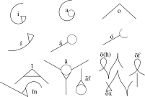
Consonants:
